SIR Article for LOP News August 2014
Sons in Retirement (SIR)
By Phil Frank 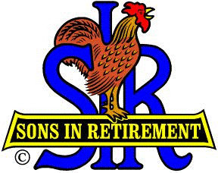

We don’t have meetings in July (to make way for LOP’s fabulous 4th celebrations), so I don’t have the usual speaker report plump paragraph for this printing. Good, you say…it’ll be shorter and maybe sweeter. Here it is:

To get us back on schedule and get our feet on dry land again, LOPer Pat (Anne) Hendrickson has offered to flavor our Wednesday, 6 August luncheon with stories and scenes of our favorite National Park, Yosemite! Credit Little SIR Elmer Curtis for that delicious choice.

Still on food, new SIR Terry Eberhardt, and especially his wife Cindie, are owed cudos for their efforts to bring the Tuesday Farmers Markets to LOP. Especially after he set us up with a great Nevada City Wine Tasting. (and others to come). You SIRtainly know how to show us how to enjoy a good, healthy meal, Terry.

Our Bocce Ball team tosses its balls with wild abandon on Tuesday nights to work up a good appetite for Wednesday lunches. Capo Bob Chan expects to report soon that the Roosters have also won a few more games for their efforts.

Smaller balls are the ammunition of our gifted golfers, as they ply the busy SIR circuit, after first planning their play on the SIR Website.

Everyone should plan ahead for SIR Fun Day – Saturday, 27 September. Al Cash will give you details or accept your volunteer offers at 268-6717.

Slightly aside from SIR, don’t forget the acronym MBS, and that it beckons all military service personnel to the Marina Lounge at 1600-1800 hours, on August 13, (and every second Wednesday), to sling some military bull.

Membership Chairman Phil Jones (268-7714) is seeing well enough again to sign up new members, so let’s keep him busy. I’ll see you all at lunch on Wednesday, August 6th!

