SIR Article for LOP News August 2015
Sons in Retirement (SIR)
By Phil Frank 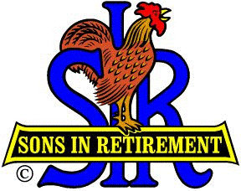

Let’s make the SIR Article for the LOP News August issue conspicuous by its absence…
Please hold your tears/cheers ‘til the September issue.

