SIR Article for LOP News January 2016
Sons in Retirement (SIR)
By Phil Frank 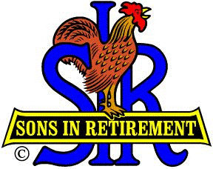

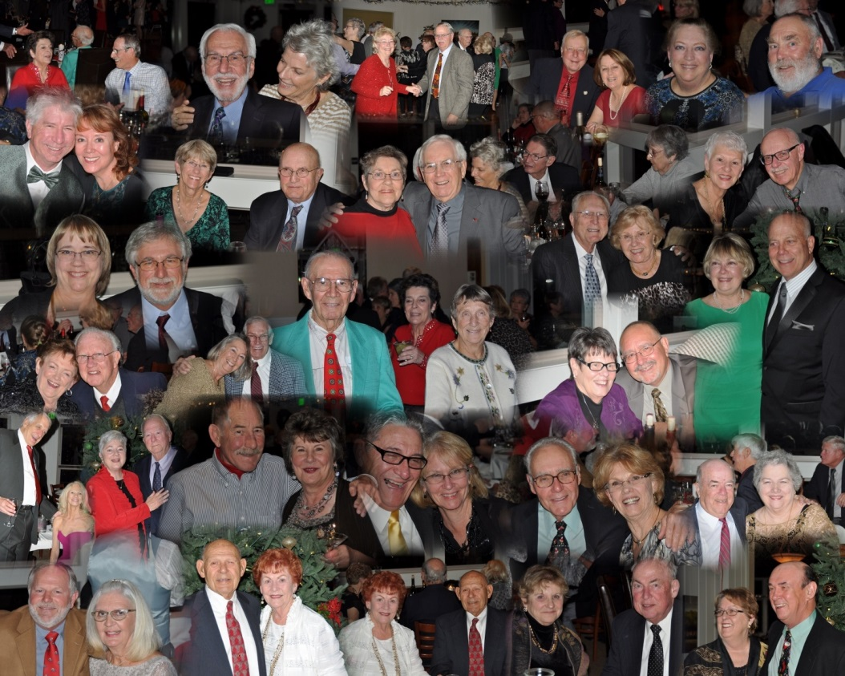
(The bigger the better, Patty…two columns?) (No caption)

The date was Wednesday, Dec 2. The bar opened at 5:30. Dinner was served at about 7:00. Our favorite band, “Mad Dash”, played from 7:30 to 10:30. It was the SIR Branch 170 Christmas Dinner Dance, and 193 SIRs and their better halves danced into the Holiday Season in good cheer! Special Credit goes to Super Supper Planners John Brewer and Steve Michalak, to Gary Resnick for rounding us all up, and then to Doers Steve Lach, Joe Lynch and their staff, for a truly tasty time.
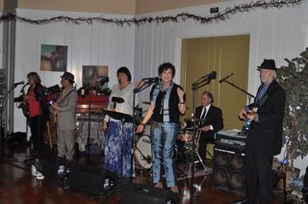
“Mad Dash”

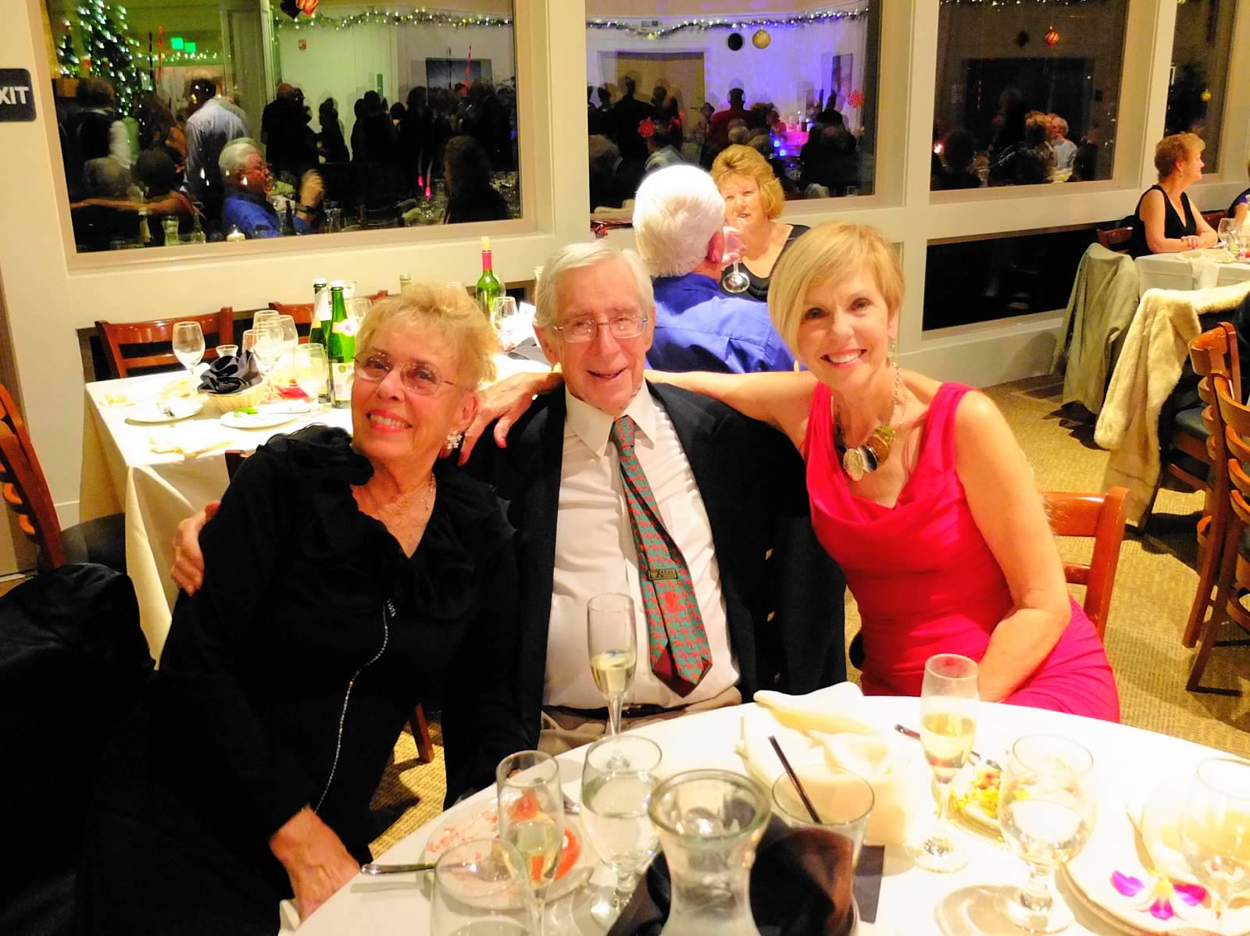
Master Planner, Honorary Lifetime Member SIR John Brewer

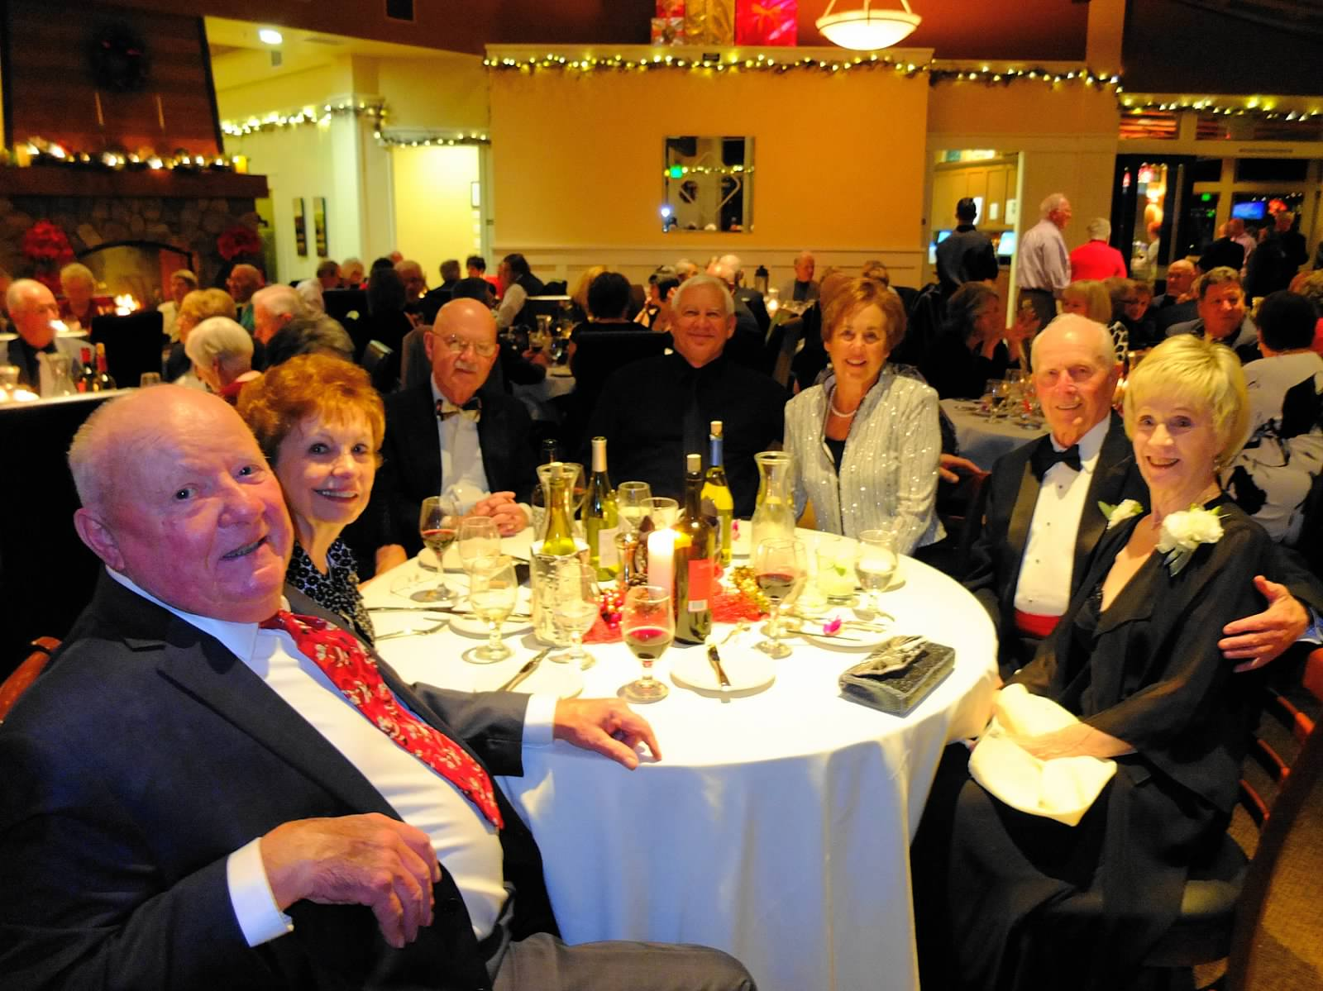
Mister Christmas, Honorary Lifetime Member SIR Steve Michalak and his Elves

Hundreds more great pix: http://branch170.sirinc2.org/archive/gallery/xmas/2015/orig.html and
https://lopsirs.shutterfly.com/pictures/327 . You’ve gotta see em!

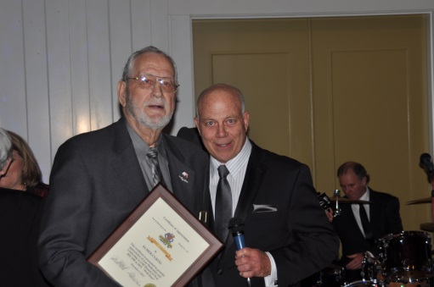
The changing of the Big SIR guard…
2015 Elmer Curtis to 2016 Ron Wolyn

In our last issue we learned who will be our officers and directors in 2016. Knowing that you’d also like to know the names of our committee chairmen, I’ll show them to you now: Dan Barbee, Bocce Ball; Bob Chan, Chaplain; Glenn Delisle, Clothing; Phil Frank, LOP News; Rich Hibbs, Bulletin; Mel Pimentel, Travel; Larry Shelley, Golf, Music, Photography, (busy body!); Ray Tschirhart, Beer Tasting; Ron Trimble, Sunshine. In a class by themselves are our Event Day Chairmen: John Brewer, Christmas Dinner; Al Cash, Fun Day; Steve Michalak, Christmas Dinner. Wow…so now you know our whole new crew! Get in touch with them to share the SIR scene.

Past Big SIRs Dick Green and Elmer Curtis report that we’ve grown to 130 members with 70% lunch attendance. Non-members, ask a SIR to invite you to a free lunch. You’ll be happy you did, and so will Dick, Elmer and the new guy at the helm, Ron.

Sneak Preview: The entertainment for the January 6th meeting will be a presentation on “The Sport of Flying Sailplanes, By (our own Little SIR) Jim Goetsch”. The presenter is a Diamond-Level Soaring Pilot who has been flying sailplanes for over twenty years. He holds the 650th Diamond Badge in Soaring in the United States since the sport began with the development of gliders by the Wright Brothers in 1902. Don’t miss it!

