SIR Article for LOP News September 2016
Sons in Retirement (SIR)
By Phil Frank 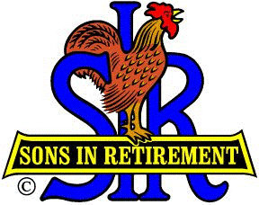

Water we gonna do to keep our produce perky and our bathtubs brimming as lower water supplies continue to be forecast? Dam it all, it’s time to proceed with the Centennial Reservoir project on the Bear River, according to our August Speaker Rem Scherzinger, General Manager of the Nevada Irrigation District. He assured us that between Rollins Lake and Lake Combie there’ll be water and power for our current and future needs, recreation, and a new bridge over the Bear. That NID cares for us in the future will be Never In Doubt.

Happily our Sons In Retirement membership has grown to 144, but sadly old friends Tom Haslett and Harry Lent, Sr. have gone on to their ultimate Retirement. We’ll not forget them.

Beer Tours: Ray Tschirhart rtshirt@suddenlink.net - There were 24 attendees at the last beer tasting outing in Loomis. They beerly had room for all of us!

Bocce Ball: Dan Barbee and Phil Jones keep our two teams rolling over their LOP competition.
They’re so good...they took third place in the SIR State tourney, too.

Food and Beverage: How’d you like that neat meatloaf lunch that Food Chairman Roger Pope and Kim Bothelio set up for us? Ahh, and that scrumptious dessert was really worth waiting for!

Fun Day: Jim Goetsch jimgoetsch@hotmail.com /Elmer Curtis ecurtis606@gmail.com – Saturday, September 10. This year’s events will be bocce ball, putting, golf and dinner. Dinner will be at the Sports Lounge. Prizes will be given for bocce ball, golf and putting. Social hour will start at 5:00, dinner will be at 7:00, and the music will start at 7:30. Dinner will be $15 per person.

Golf: Ron Wolyn nornylow@aol.com will once again lead our lowly (scoring) SIR golfers to great heights at Auburn Valley on Mon 9/19…just as he did at Black Oak and Whitney Oaks in August. That’s Oak by me, too!

Singing??: Larry Shelley - Our own “King of the Road” led us down one like Willy’s.

Success!: Little SIR Jim Goetsch and Bob Chan attended the SIR state meeting. Branch 170 was awarded the “Presidents Certificate for Success”. (For growing our membership, I guess.)

Wine Tasting: Terry Eberhardt teberhardt@suddenlink.net - Did our August sipping at Smith Vineyard, Grass Valley top June’s at Montoliva in Chicago Park? Ya gotta go to know. Terry will tell you when in October.

Zee Free Lunch? Mais oui! Old-timer John Brewer showed Newcomer Dave Medlicott how to grab a free dejeuner. Bon Appetite to both at our next meeting, on Wednesday, September 7th.

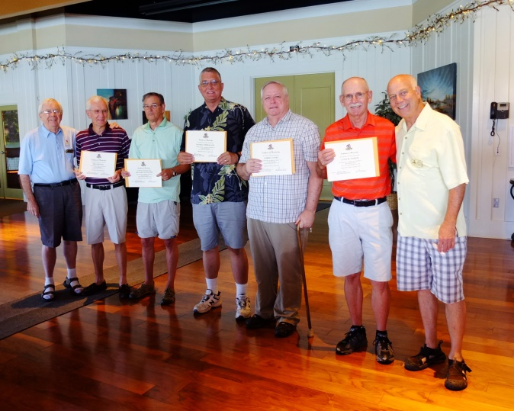
Membership Chairman Phil Jones, Bill Benner, Richard Whitmore, David Medlicott, Loren Ayers, Lonn Fisher & Big SIR Ron Wolyn

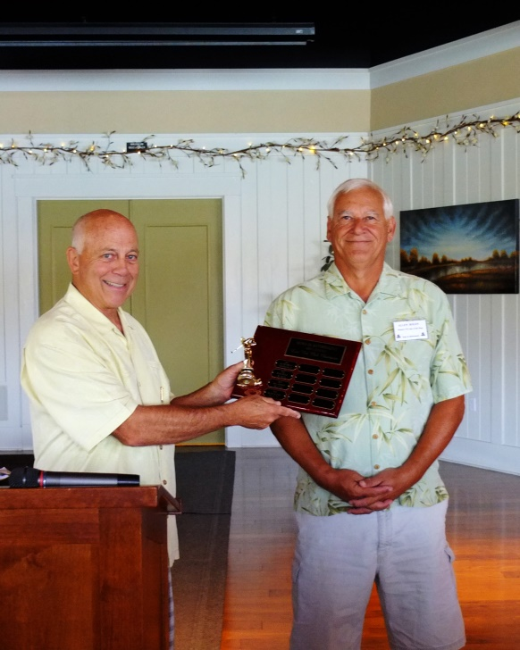
Big SIR Ron Wolyn is high on Allen Bolen's Low Net Golf Award

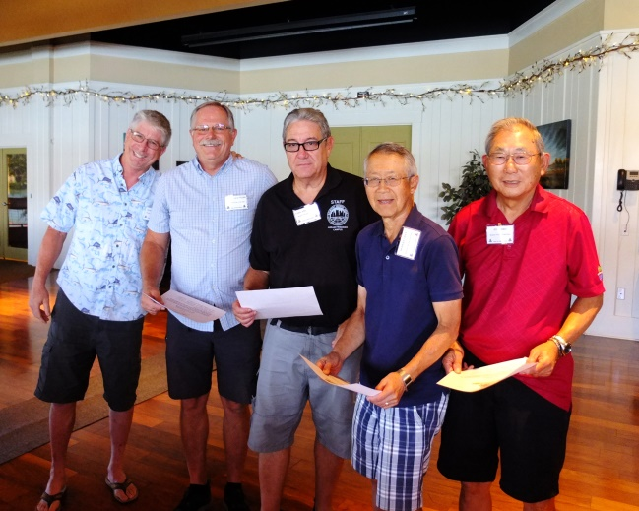
Our Bocce Ball rollers of the roost: Cappo Dan Barbee, Don Clausnitzer, Andy Ameigeiras, Bob Chan & Jim Shiro
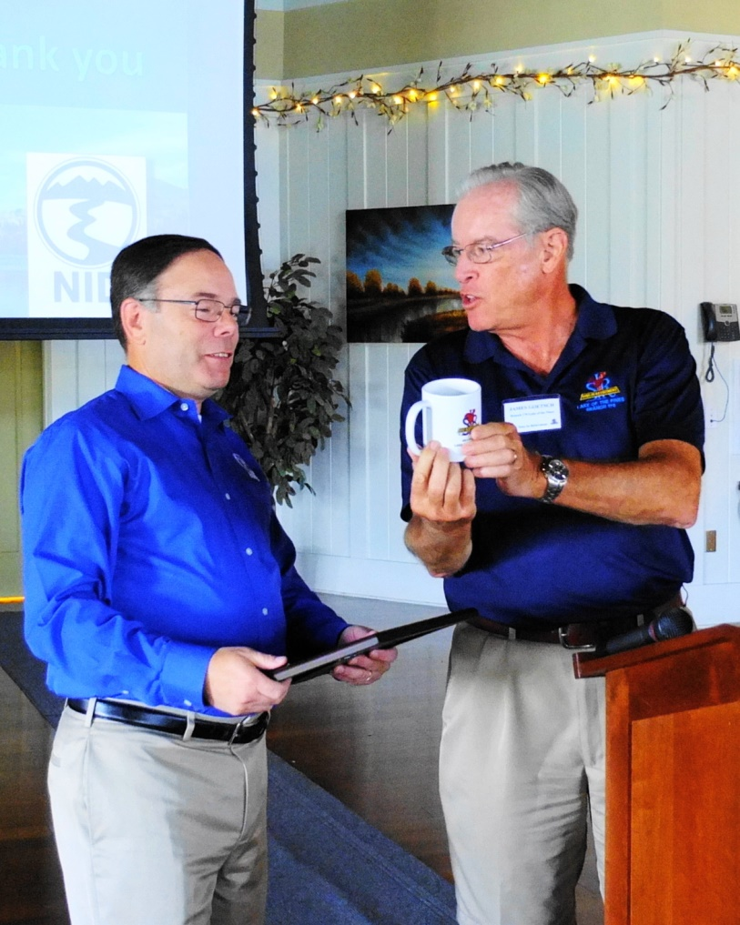
"A great place to store your NID Water", says Little SIR Jim Goetsch to GM Rem Scherzinger

