SIR Article for LOP News October 2016
Sons in Retirement (SIR)
By Phil Frank 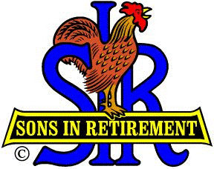

Things we remember with relish:
Bocce Ball 8/16 Our 2 teams were winners…Rooster 2 advanced to State Finals
Wine Tasting 8/19 Smith Vineyard Tasting Room in Grass Valley
Travel Show 8/23 @ Sports Lounge
SIR Branch 170 Lunch Meeting 9/7
Welcomed four new members…100 of our 144 squeezed in!
Elected 2017 officers and directors. No…only 14…for next year, silly.
Neighborhood Watch program introduced by Rich Goldsberry
Scoutmaster Michael Brown, of our Local Boy Scout Troop 783, took us on a 5400 mile audio-visual
Florida Sea Base Adventure. The sailing, fishing, scouting trip that he shared with his son’s troop is an
adjunct to more than 150 Merit Badge programs offered today’s youth.
Beer Tasting @ Moonraker Brewing Co. 9/23
Fun Day 9/10 Bocce Ball, Putting, Golf, Dinner…SIRs & Gals…FUN!!!
Golf: Empire Ranch 9/26…did Allen Bolen win again?

People to encourage to, or congratulate on, a quick recovery:
Terry Fenstermacher, kidney removal +
Rod Hopkinson, whatever
George Thorsen, heart attack & the stent stint
Ron Trimble, kidney stone

Things to plan for:
Our next lunch 10/5 Free lunch winners: Elmer Curtis (born hungry in September) and Al Cash
(stayed enthralled to the end of Michael Brown’s great presentation).
Military Bull Sessions 10/12 (2nd Wednesdays) Marina Lounge 1500-1700 hrs
Golf 10/17 Dark Horse 2 man best ball Ron Wolyn nornylow@aol.com
Beer & Wine Tasting 10/21? TBA by Ray Tschirhart at (714) 392-9282 or Rtshirt@suddenlink.net &
Terry Eberhardt 278-3362 or teberhardt@suddenlink.net
SIR Lunch 11/2 (again?...must be a 1st Wednesday)
Golf 11/14 Black Oak Turkey Shoot Ron Wolyn nornylow@aol.com
Blood Drive 12/4 Sunday in the upper marina parking lot.
Christmas Dinner/Dance Party 12/7 food and frivolity for all! (Booking deadline 11/2)
You phil in the rest…12/?? +

340
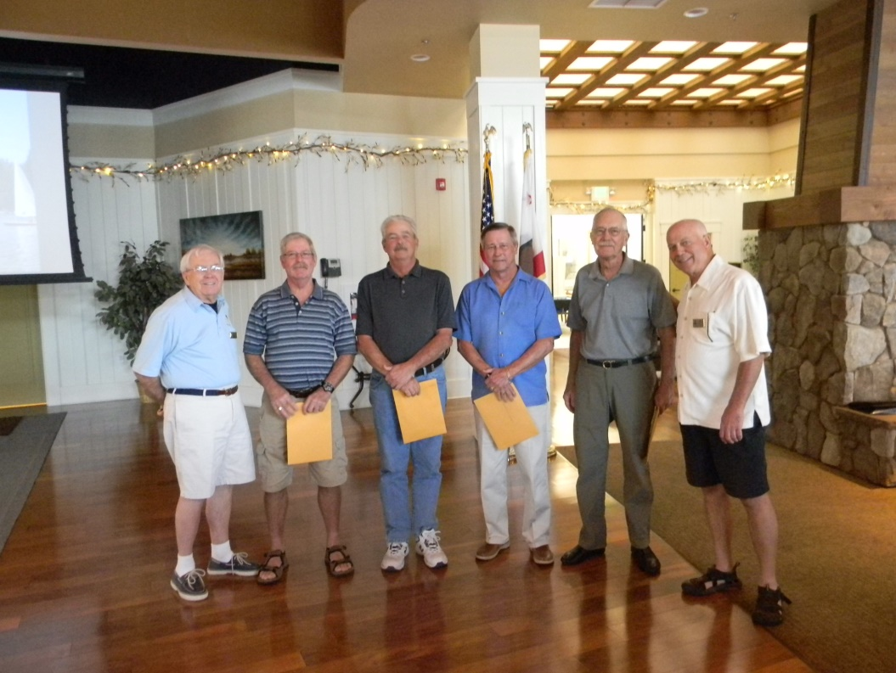
Bookends Phil Jones and Ron Wolyn welcoming new editions
Gary Willhite, Tim Emerson, Larry Jacobsen & Bill Brothen
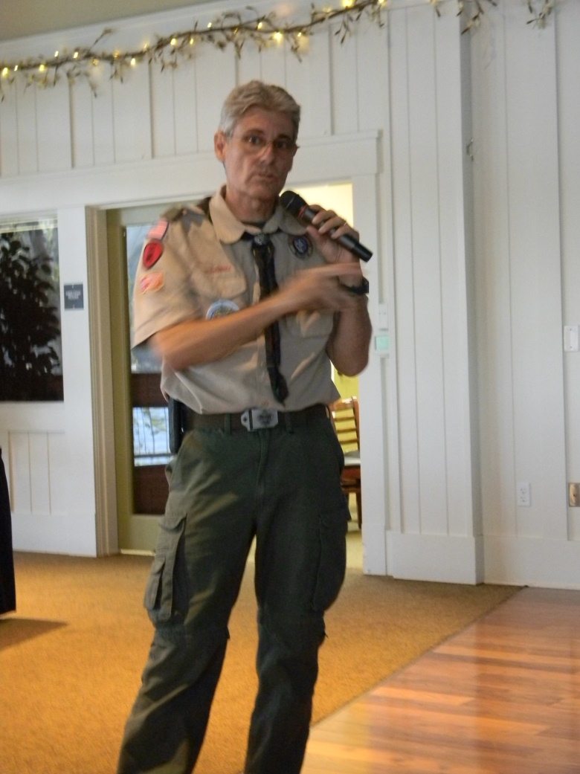
Speaker/ Scoutmaster Michael Brown
Fun Day
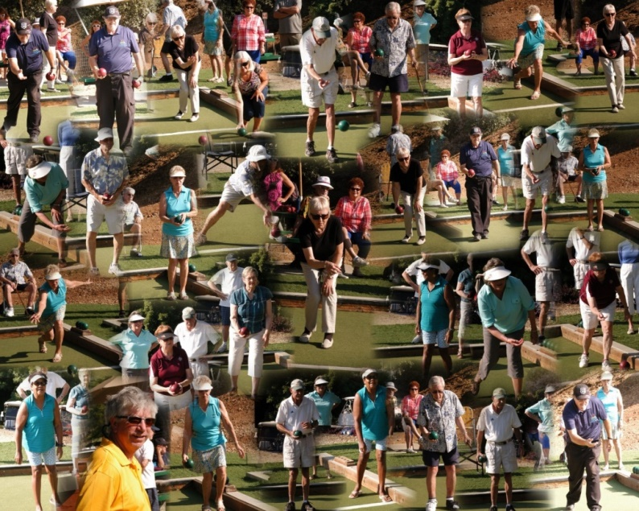 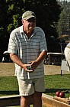 Bulletin Boy/Bocce Ball Buff Rich Hibbs Bocce Ball…Bravo, Brava!
Peggy Brewer Poised to Putt 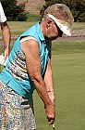 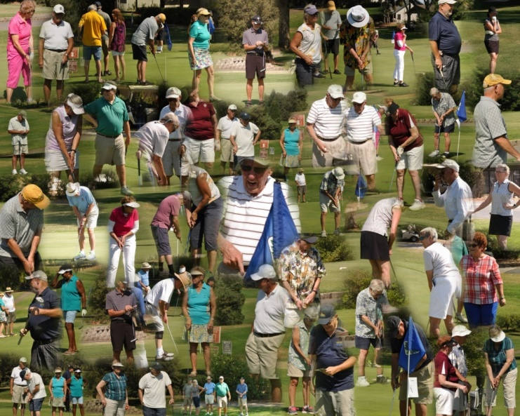 Puttee, puttee!
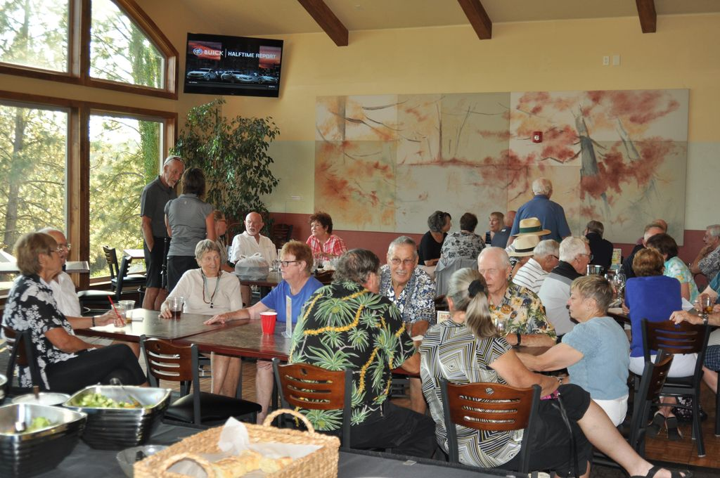 The Fun Feast Finale

