SIR Article for LOP News November 2016
Sons in Retirement (SIR)
By Phil Frank 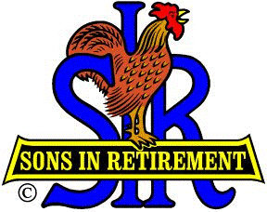

:htnom tsal dah ew nuf eht no kcab gnikooL

9/26 Golf @ Empire Ranch…our boys’ play wasn’t raunchy at all…see all the cash they won?

10/5 Current membership count is 150 . We have six members over the age of ninety: Bill Swenson, Al Jose, Leif Sundblom and now Don Barnett are Senior Members, lead by Bill Hagin, over 95, our Super Senior Member. Lingering at luscious SIR lunches leads to longevity! Today’s tendered a tasty Chicken Tetrazzini.

Our lunch speaker was a Nevada City neighbor, Mark Lyon. He is a professional actor and a parapsychologist. I shouldn’t say that he is a spooky speaker, but his subject sure was. He’s a consummate actor and storyteller, superbly suited to serving up scenes of the supernatural. Mark’s ghostly presence at our meeting was a perfect precursor to a haunting Halloween. He’s so good, and so local…y’ought’a go on one of his “Haunted Nevada City” (or Grass Valley) tours. mlyon@hauntedisles.com .

10/17 Golf @ Dark Horse …if they didn’t win sweeps, at least they saved on gasoline money.

10/21 The joint was jumpin’ at Final Gravity Taproom & Bottle Shop, in Auburn, when we bellied up for our joint beer/wine tasting. Terry Eberhardt and Ray Tschirhart deserve our toasts for that fun.

Now! Terry Eberhardt will insure that you have a happy New Years in Nashville! <> Dec 30-Jan 3, 2017
Stay Opryland Hotel, NewYears Eve on the General Jackson Showboat! Call him @ 278-3362 or email teberhardt@suddenlink.net for this and many more marvelous tours.

Looking forward for the fun in our future:

11/2 Our next meeting and munching. Lady Luck will let Leif Sundblom and Bill Swenson in for free lunches. Last chance to sign up for Christmas Party.
11/14 Golf @ Black Oak (Two rounds for the price of one…less your winnings!)
12/4 Blood Drive – Ron Trimble might say: “Park your carcass in the Marina Parking Lot and donate a Lot of blood!” But, sooner, he’d also like you to wish Terry Finstermaker, Lee Hicks, Rich Knowlden and Ed Tozer much better health.
12/ 7 Christmas Dinner and Dance – John Brewer and Steve Michalak are arranging a great one. John and bass player Mickey Bennett will play during cocktail hour and our favorite combo, Mad Dash, will play for dancing.

N th mntm, sty hppy nd hlthy !

455

(Include photos below)
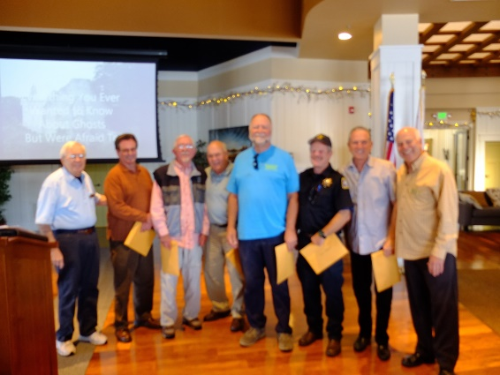
Membership Chairman Phil Jones, New Members Jim Plumley, Bill Stenwick,
Terrel Jackson, Robin Friesen, Guy Frank, Tom Wright & Big SIR Ron Wolyn

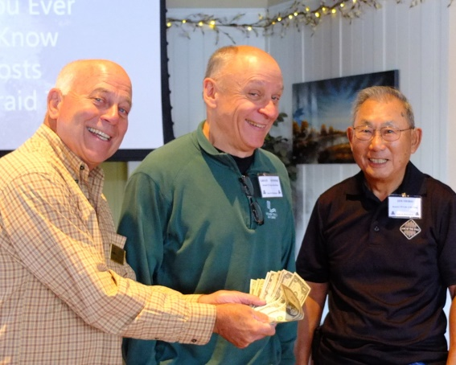
Gleeful golfers Ron Wolyn, Grego Kosinski & Jim Shiro

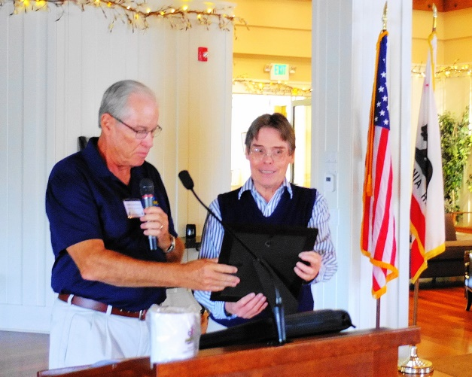5
Little SIR Jim Goetsch & Mark Lyon
It ghost to show you...ghostly speakers show up at SIR lunches!

