SIR Article for LOP News December 2016
Sons in Retirement (SIR)
By Phil Frank 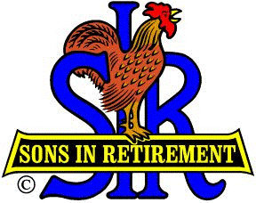

Our presenter on November 2nd was the peripatetic Publisher of The Union of Nevada County, Don Rogers. I liken him to Phileas Fogg, the newsworthy subject of “Around the World in Eighty Days”, because he seems to have meandered almost as much, making news wherever he went. From his start as a firefighter and publisher of six papers in not-so-far-away Quincy, he reported for and published papers in Holland MI, Auburn and San Diego CA, Vail CO, and now his and our own Grass Valley! Don shared his perspective of the county from someone who just recently moved here, in April of this year, to assume his new position. It was enlightening to get the inside scoop from someone who now has contact with the "movers and shakers" of the journalistic world and of Nevada County.

If you’re a SIR who needs to get out of town real quick, Terry Eberhardt is fast! Reach him at 278-3362 or teberhardt@suddenlink.net. If you have more time to pack, he can neatly outfit you and yours with tickets to Savannah & Charleston, an Albuquerque Balloon Fiesta or cruises on the Panama Canal or the Danube River. Make 2017 your “Ferry with Terry” year.

Closer to home, Terry’s wife, Cindie, invited us to join her, and other Daughters of the American Revolution, to participate in the Wreaths Across America Ceremony at St. Patrick’s Cemetery on Saturday, December 17th, at 11:00 a.m. (Rough and Ready Highway in Grass Valley.) They plan to place 275 wreaths at graves to show our respect to our Veterans.

As I write, my crystal ball tells me that our Roosters will be crowing again, as usual, at the 11/14 season ender Black Oak Turkey Shoot. They’ve had a great season, ruling the roost.

Have you noticed the splendid display of SIR haberdashery lately? Glen Delisle and Jim Goetsch have done a fine job of draping dozens of our Dapper Dans with new Branch 170 duds. Their tee shirts and caps are due to dominate the next Red Carpet.

We’ve been waiting all year for it…John Brewer and Steve Michalak, (and many more), will be looking for you at the Clubhouse door, on Wednesday, December 7th at 5:00 p.m., for music and food and dancin’ and much more! I’m talkin’ about the SIR Branch 170 Christmas Dinner Dance Party! Merry Christmas, everyone!

(No need for doggy bags after that feast, Roger Pope, Bill Brothen and Jim Plumley…you won Free Lunches for our next lunch on Wednesday, Jan 4!)
486

See 4 photos below:

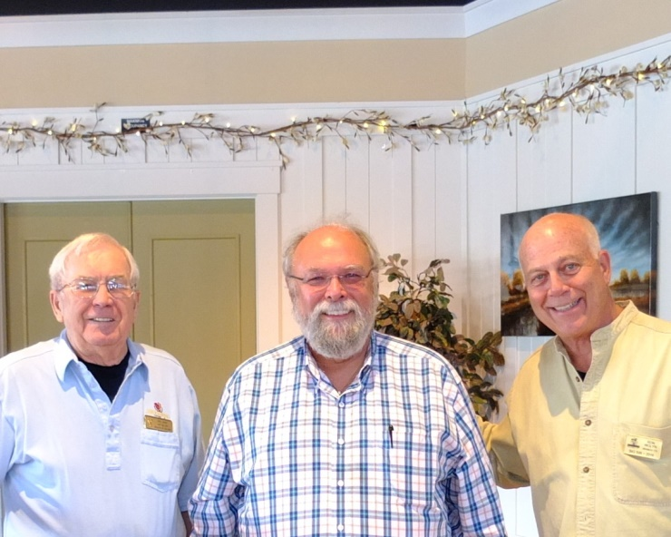
Membership: Chair Phil Jones, Recruit Marc Loranger & Big SIR Ron Wolyn
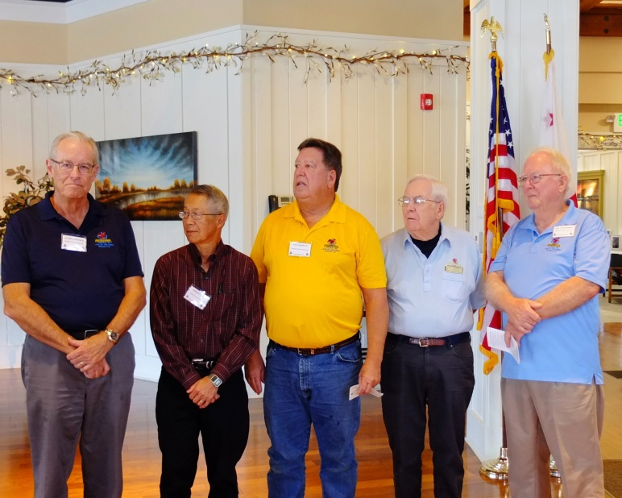
2017 Officers: Big SIR Jim Goetsch, Little SIR Bob Chan, Treasurer Pat Graham, Membership Chairman Phil Jones & Secretary Hal Hawthorne
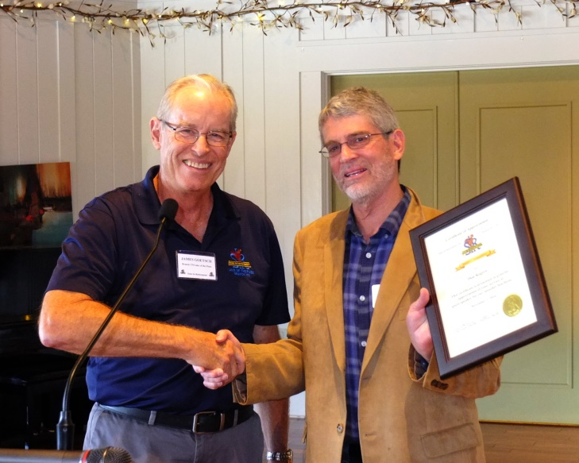
Little SIR Jim Goetsch & Speaker Don Rogers
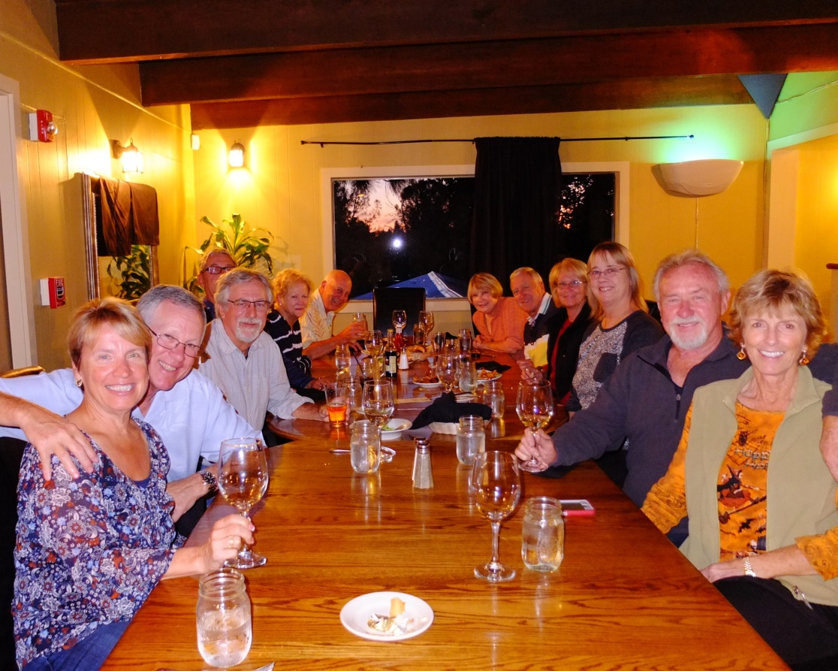
Our brew crew at Final Gravity Taproom & Bottle Shop

