Sons in Retirement (SIR)
By Jim Goetsch 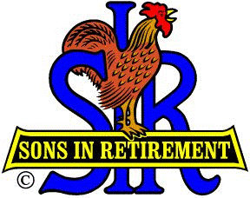
We SIRs finished out 2016 with our Annual Christmas Dinner Dance on Wednesday, December 7th. The spouses and significant-others of our members were decked out to wow one another and to incidentally impress the men. As usual it was the event of the season with thanks to a number of members, including John Brewer and Steve Michalak (Honorary Life Members), as well as Gary Resnick, Hal Hawthorne, Roger Pope, Pat Graham, and others. Phil Frank fairly well encapsulated the entire event in last month's LOP News report despite the fact that it had not yet taken place when he wrote it. Not bad for a reporter to be ahead of the news.
By the end of the year we found we had lost two of our members: Bill Andre died on December 8, the day after our Dinner Dance, and Leif Sundblom died on Christmas Day. Both had been valued members of SIR and will be missed. Leif's son, Charlie Sundblom, held a Celebration of Life for Leif on January 14th at his home. Our prayers go out to the families of both men.
We also gained two new members for this first meeting. Gordon Boyer and Duane Heaton were received into our SIR Chapter 170 after attending an earlier SIR meeting in November to check us out. Welcome!
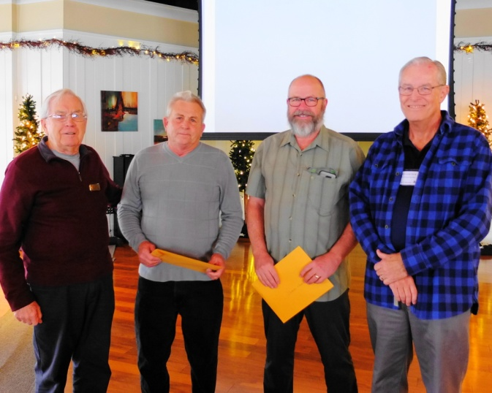
Our new members, Gordon Boyer and Duane Heaton in the middle, flanked by Phil Jones our Membership Chairman, and Big Sir, Jim Goetsch.
We kicked off the new year on January 4th with a new Big SIR, Jim Goetsch, and a new Little SIR, Bob Chan. Bob arranged to have our own SIR member, Grego Kosinski, update us on the Darkhorse development plans. Grego is the President of the Homeowners Association at Dark Horse and spoke knowledgeably about the Asia Pacific Group (APG), which is attempting to add a number of single-family homes and some high-end duplexes to areas along the golf course. He has agreed to keep us informed as to future developments, because LOP can be impacted by some of these plans depending on how they work out.
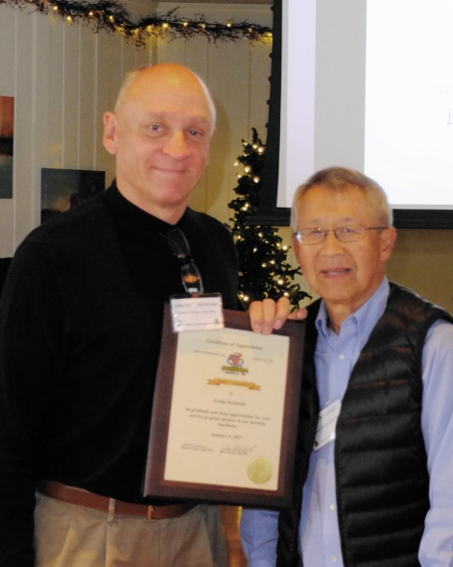
Our presenter, Grego Kosinski, with Little SIR, Bob Chan
Our Golf Chairman, Ron Wolyn, presented the winners of the December SIR Golf Match with their first place winnings in both the first and second flights - $15 each. These were four-person teams playing in a best-ball format. Ron mentioned that some of the other SIR Chapters may ban us from playing based on the success of our players. I guess it helps to have a course as unforgiving as ours on which to practice.

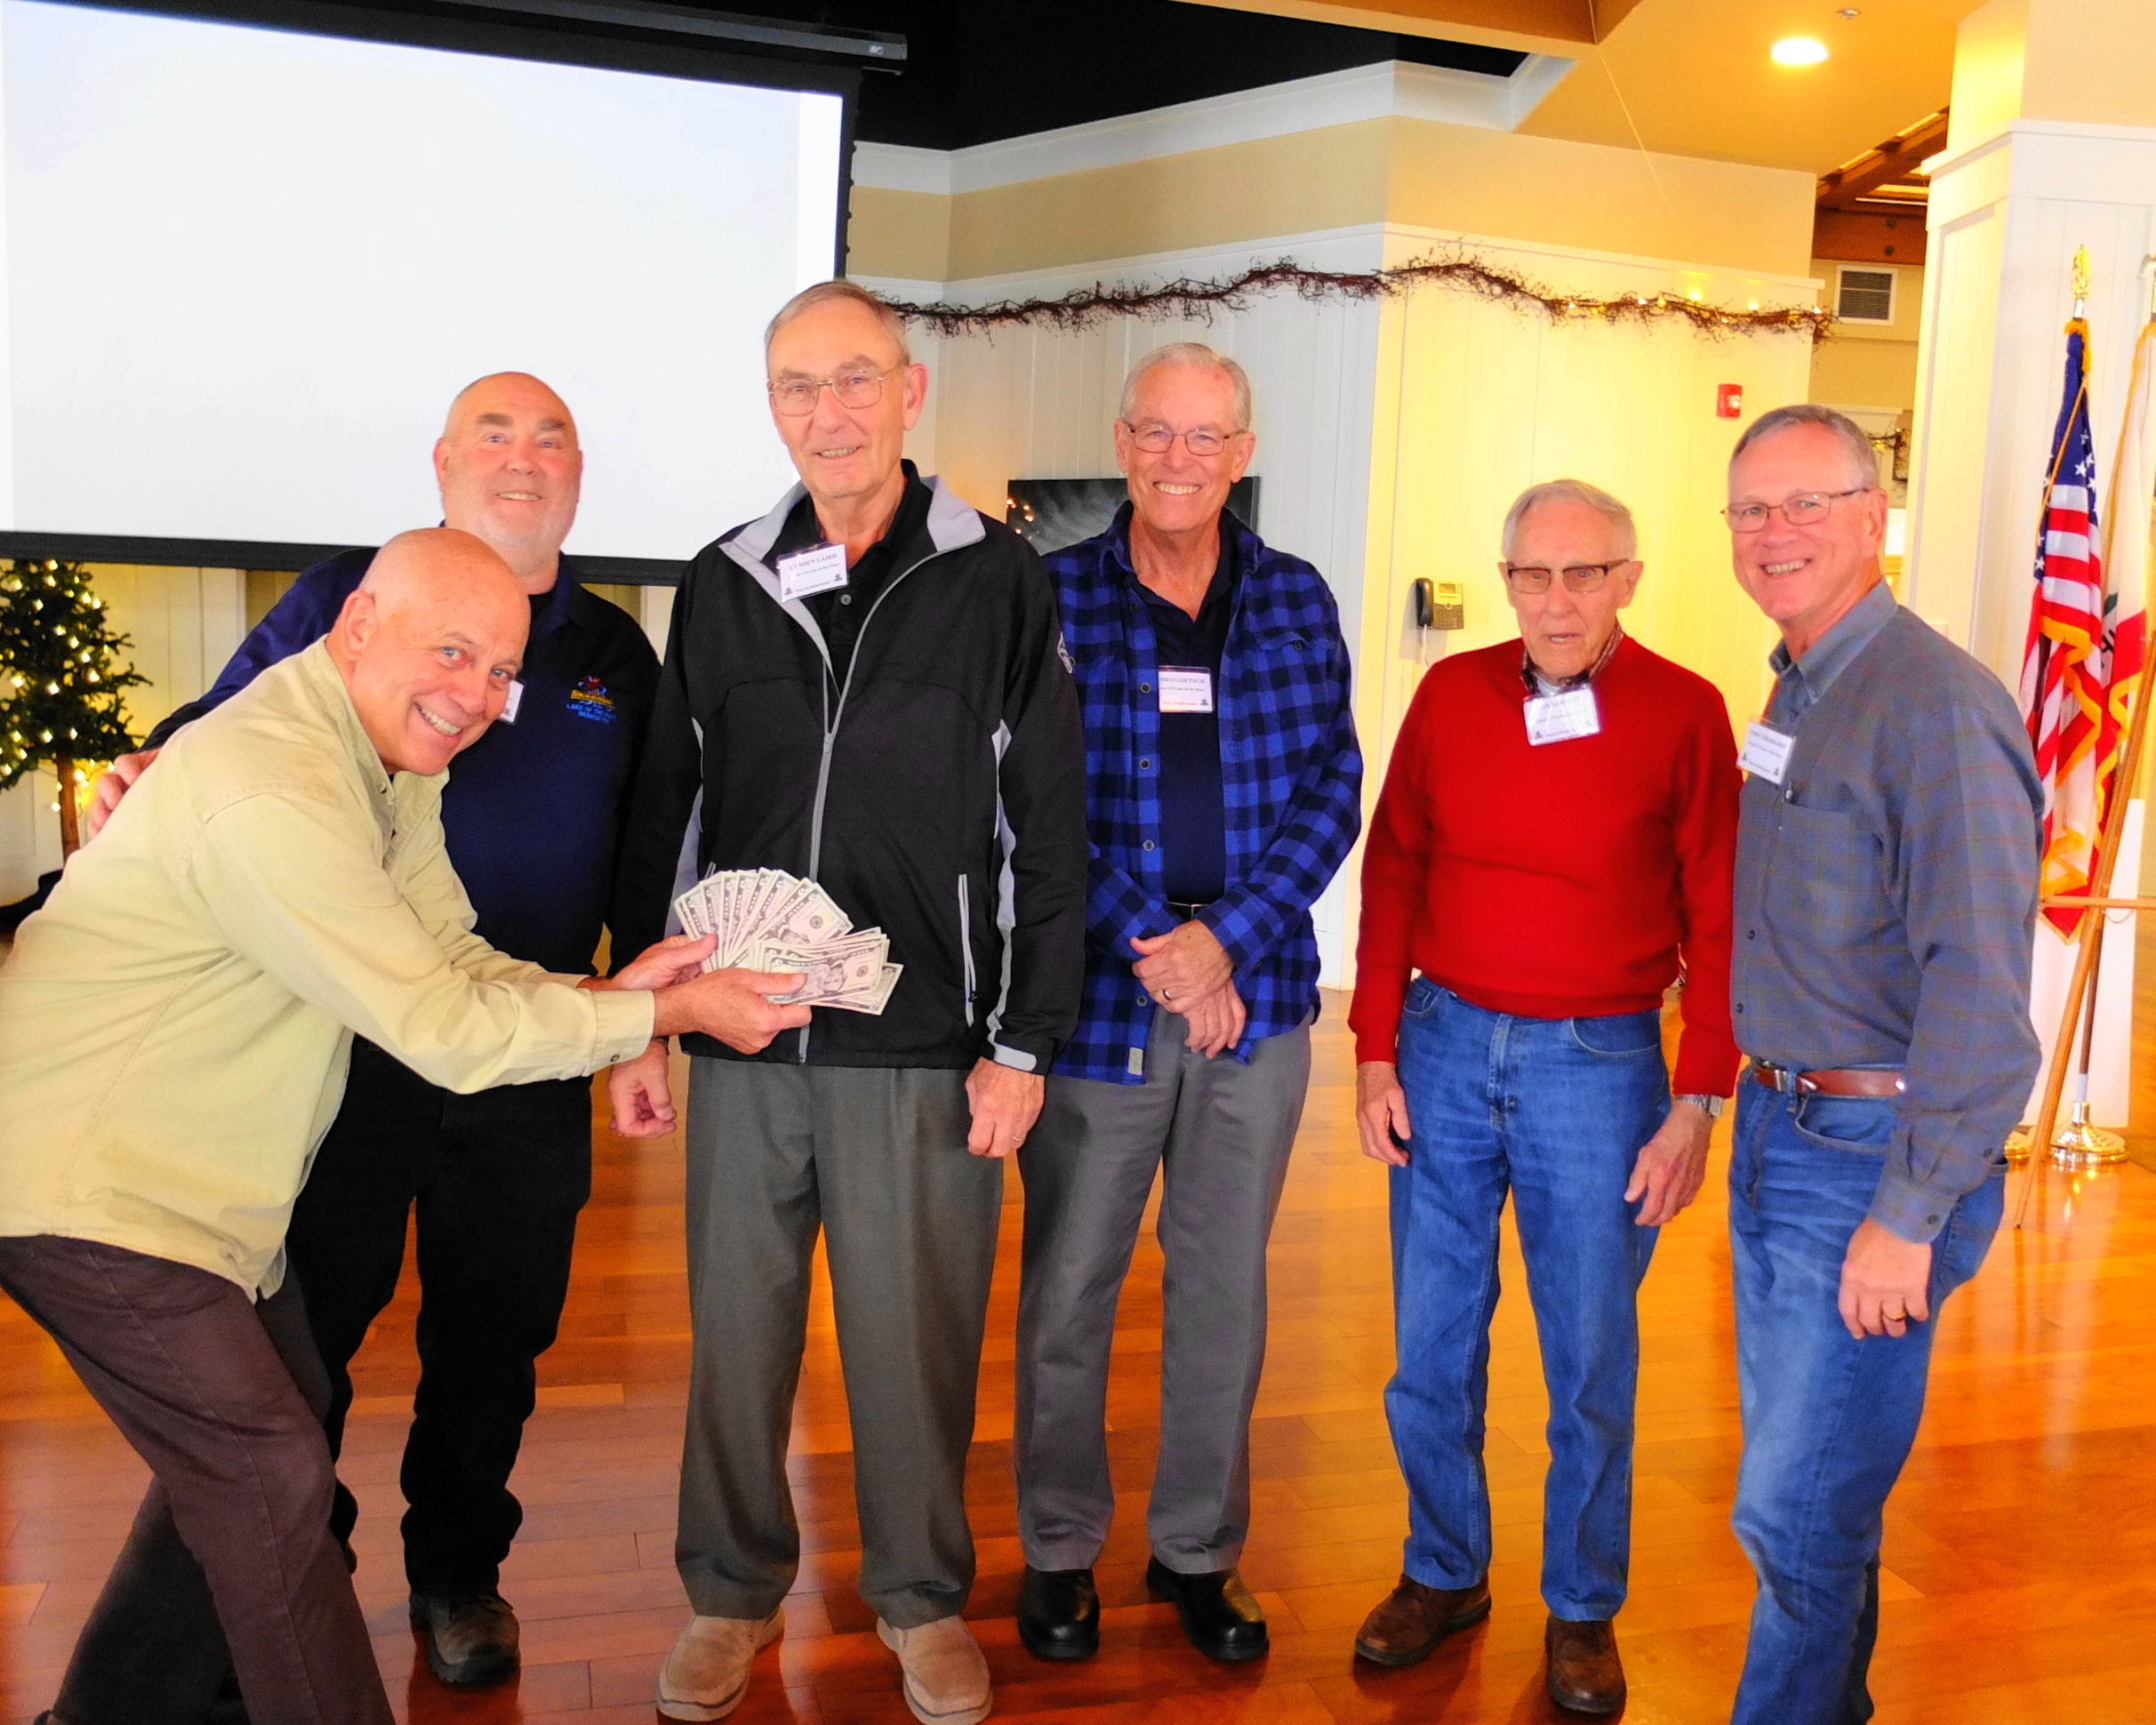
Ron Wolyn presenting winnings to himself, and from left to right, Jim Gunn, Lynden Laird, Jim Goetsch, Don Barnett and Terry Eberhardt. Not pictured: Robert Reeder and Ray Tschirhart

For next month we are looking forward to Our speaker for the February luncheon, Ms. Barbara Jenness, who is the owner of the Wheyward (hey guys, it's whey, NOT way) Girl Creamery in Nevada City. She will explain the cheese-making process and may even bring some samples. We look forward to seeing all our members there on February 1st along with any LOP men who are interested in getting to know some other men in this very active community - a good way to make friends.

